**CERTIFICATE**

*This is to certify that Ms.* ***Liza Bharatkumar Lad***

*with enrolment no.* ***2003031080087*** *has successfully completed her laboratory experiments in the* ***Computer Networks(203105256)*** *from the department of .****Information Technology*** *during the academic year* ***2020-2021***



Date of Submission: ......................... Staff In charge:...........................

# Head of Department: ...........................................

|  |  |  |  |  |  |  |  |
| --- | --- | --- | --- | --- | --- | --- | --- |
| **Sr. No** | **Experiment Title** | **Page No** | | **Date of Performance** | **Date of Assessment** | **Marks (out of 10)** | **Sign** |
| **From** | **To** |
| 1 | Experiments on Simulation Tools: (CISCO PACKET  TRACER). |  |  |  |  |  |  |
| 2 | Experiments of Packet capture tool: (Wireshark). |  |  |  |  |  |  |
| 3 | To study behavior of generic devices used for  networking: (CISCO PACKET TRACER). |  |  |  |  |  |  |
| 4 | Data Link Layer (Error Correction). |  |  |  |  |  |  |
| 5 | Virtual LAN. |  |  |  |  |  |  |
| 6 | Wireless LAN. |  |  |  |  |  |  |
| 7 | Internetworking with routers. |  |  |  |  |  |  |
| 8 | Implementation of SUBNETTING. |  |  |  |  |  |  |
| 9 | Routing at Network Layer. |  |  |  |  |  |  |
| 10 | Experiment on Transport Layer. |  |  |  |  |  |  |

**PRACTICAL – 1**

**Aim :** Experiments on Simulation Tools (CISCO PACKET TRACER) :

**Introduction :**

* Packet Tracer is a cross-platform visual simulation tool designed by Cisco systems that allow users to create network topologies and imitate modern computer networks
* Packet Tracer makes use of a drag and drop user interface, allowing users to add and remove simulated network devices as they see fit.
* Packet Tracer supports an array of simulated Application Layer protocols, as well as basic routing with RIP, OSPF, EIGRP, BGP, to the extents required by the current CCNA curriculum.
* Packet Tracer allows students to design complex and large networks, which is often not leasable with physical hardware, due to costs. Packet Tracer is commonly used by CCNA Academy students, since it is available to them for free.
* Packet Tracer can also be run on Linux and Microsoft Windows and also macOS. Similar Android and [iOS](https://en.wikipedia.org/wiki/IOS" \o "IOS) apps are also available.
* WORKSPACE:
* Workspace This is the main area where the devices are placed, designed and different information like router Name, interface names etc. are seen
* The workspace is the place where all the components (routers, switches, end devices, firewall, servers and etc.) are placed and wired together to send and receive the packets.
* Workspace of Cisco Packet Tracer is very much flexible from the user point of view as it is a drag-and-drop workspace through which they can drag-and-drop the components and starts configuring it beforehand using the built-in bash command window which actually simulates the bash window of the real router.

Workspace of Packet Tracer:

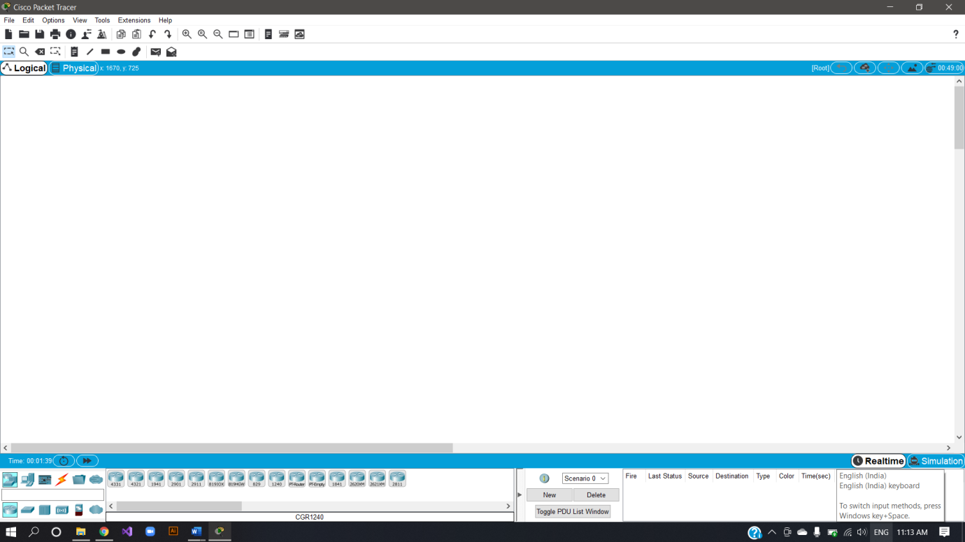

Topologies :

Topology defines the structure of the network of how all the components are interconnected to each other. There are two types of topology: physical and logical topology.

There are five types of topologies :

1. Bus Topology
2. Mesh Topology
3. Star Topology
4. Ring Topology
5. Hybrid Topology
6. Tree Topology
7. Bus Topology

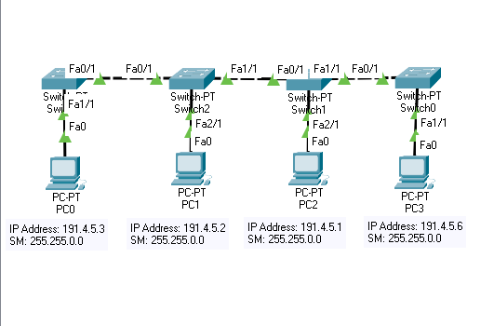

1. Mesh Topology

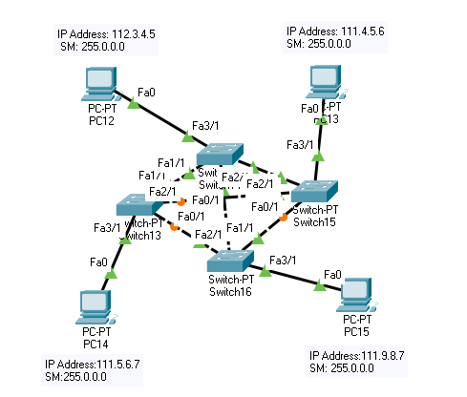

1. Star Topology

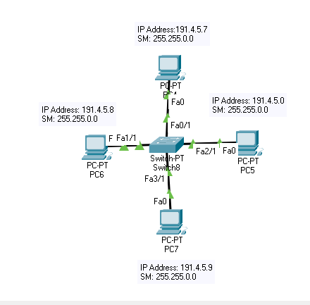

1. Ring Topology

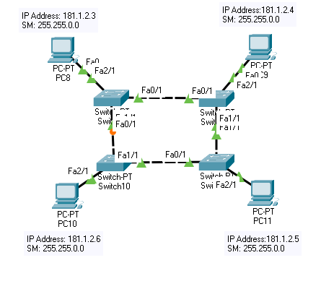

1. Hybrid Topology

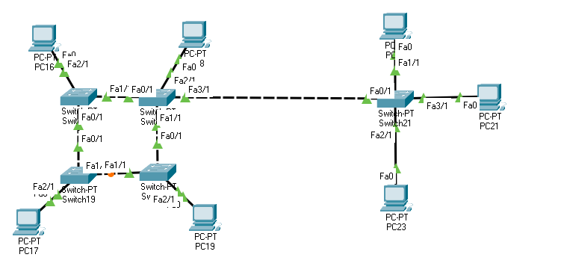

1. Tree Topology

